Postman requests from Pokemon API

1. <https://pokeapi.co/api/v2/pokemon>

A list of all pokemons 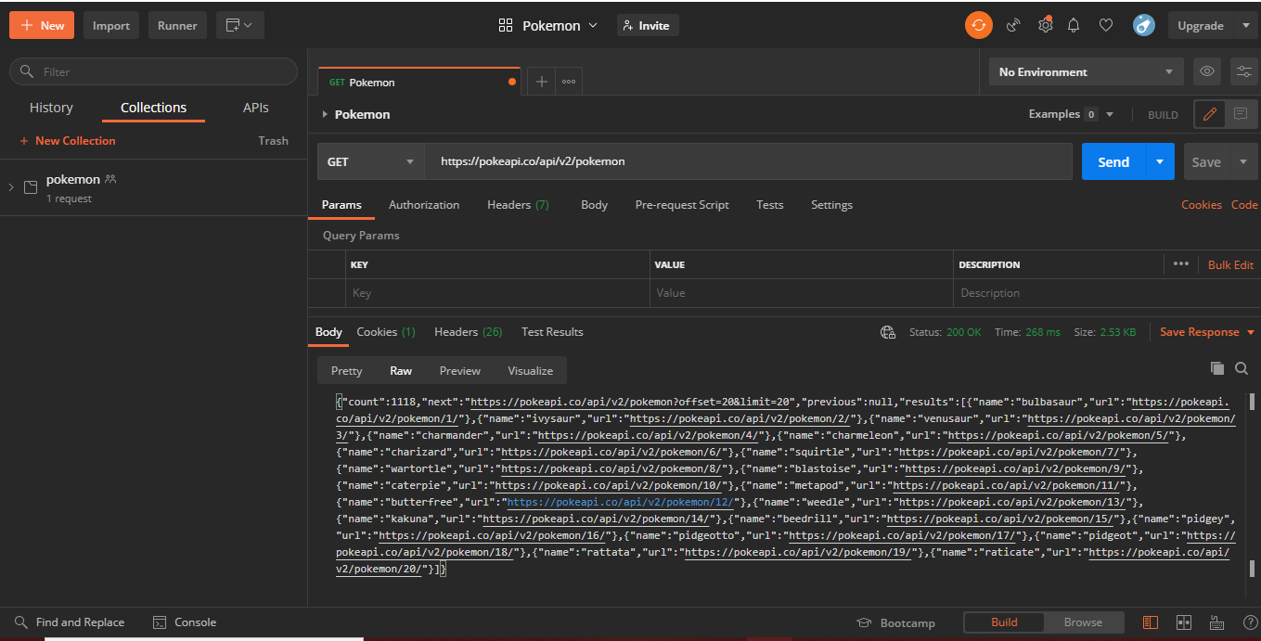

1. <https://pokeapi.co/api/v2/pokemon/26>

Get a pokemon by ID 🡪 pokemon number 26

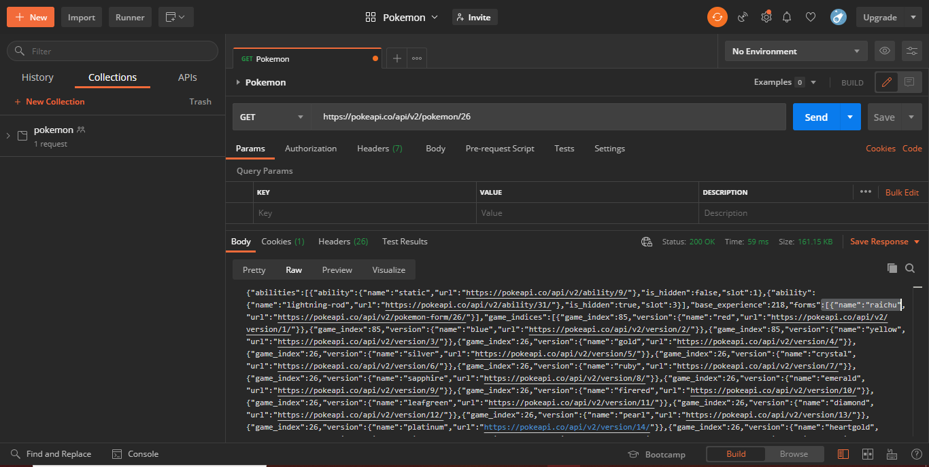

1. <https://pokeapi.co/api/v2/berry/6>

Pokemon Berries

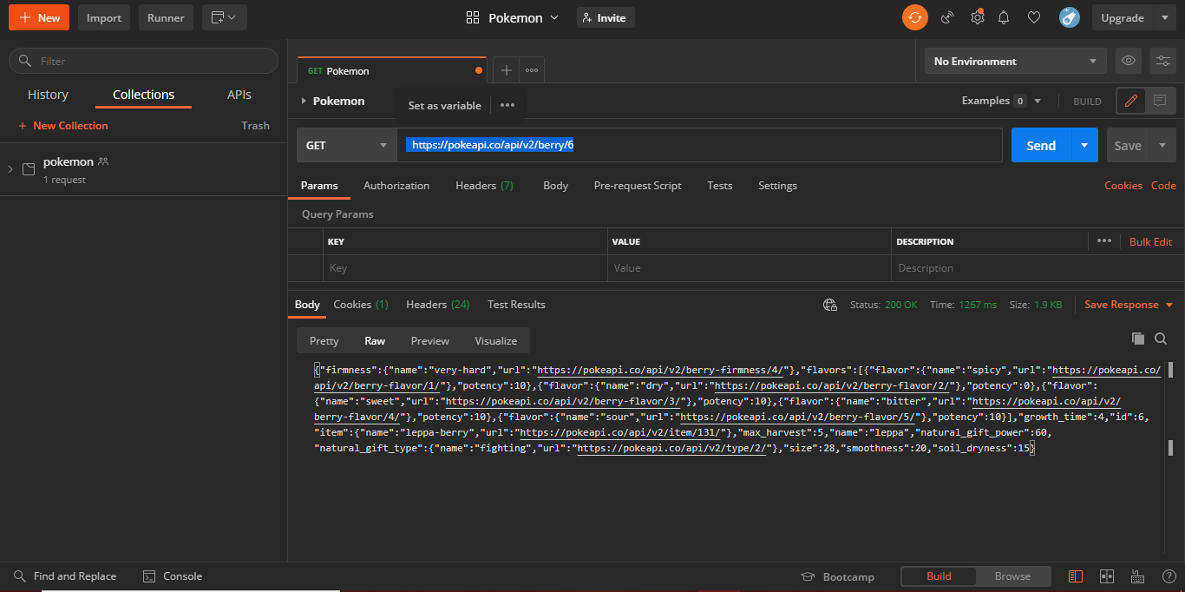

1. <https://pokeapi.co/api/v2/encounter-method/8>

Encounter Method (id = 8)

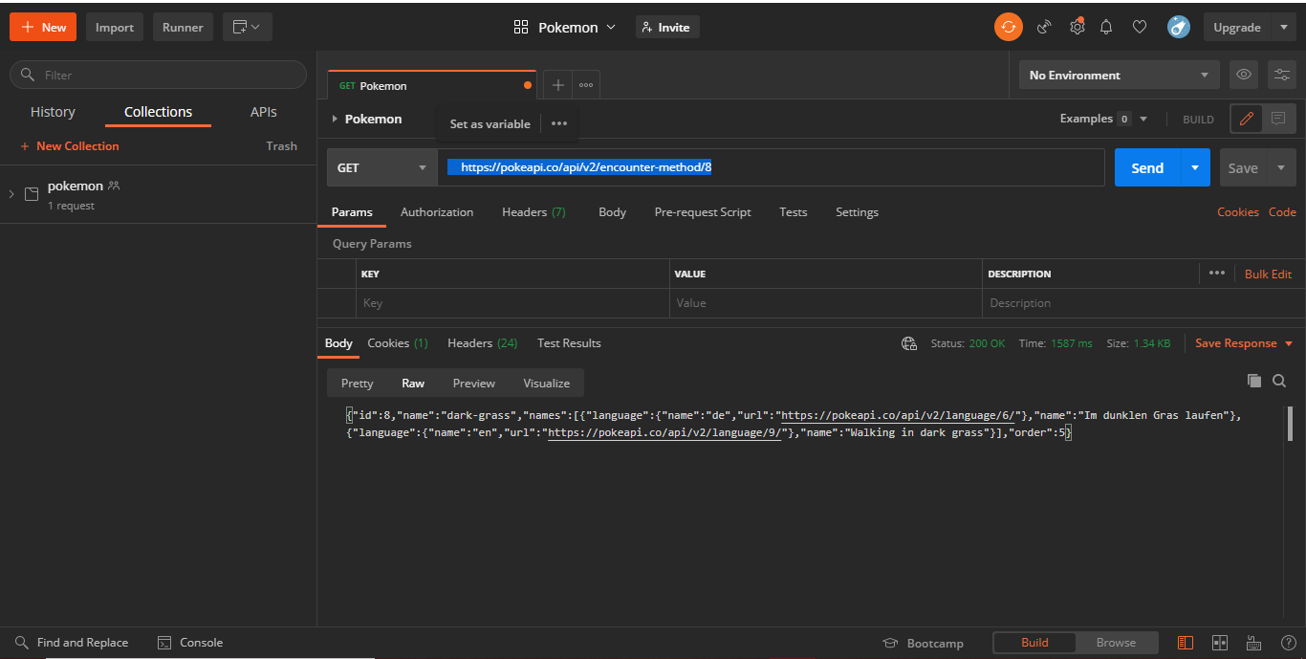

1. <https://pokeapi.co/api/v2/generation/6>

Generation

